Wilson Receivers Glove
Price: Approximately Rs 7,500
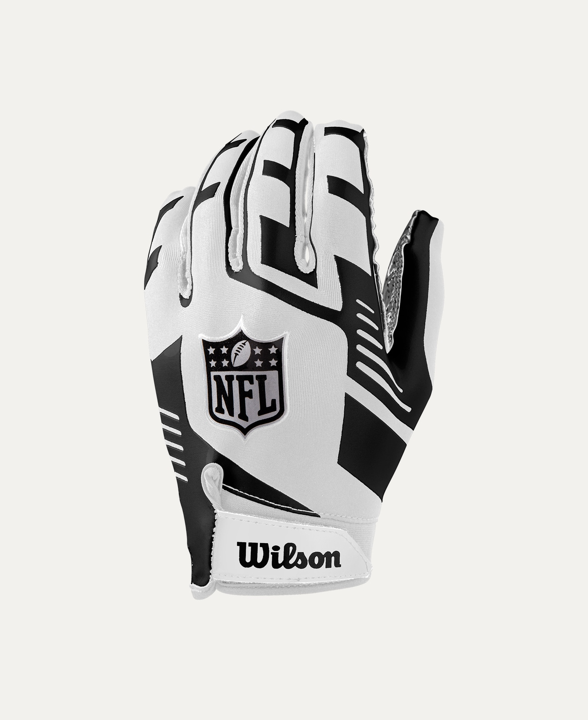
Introduction
The Wilson Receiver’s Gloves are designed to enhance grip, control, and confidence during football play. Built for speed and precision, these gloves help receivers secure catches in all weather conditions.

Product Overview
These Wilson Receiver’s Gloves feature advanced grip technology and a flexible fit to support quick hand movements. They provide excellent ball control while maintaining comfort throughout practice and games.

About the Brand
Wilson is a globally recognized sports brand and a trusted name in football equipment. Wilson gloves are designed using professional insights to deliver performance, durability, and reliability.

Key Features
- High-grip palm for secure catches
- Flexible and lightweight design
- Breathable material for comfort
- Adjustable wrist closure for secure fit
- Suitable for training and match play

Design & Build Quality
The gloves feature a sleek, athletic design with reinforced stitching in high-stress areas. Their ergonomic shape supports natural hand movement and responsiveness.

Storage & Capacity
Compact and easy to store in sports or gear bags without losing shape or grip quality.

Material & Durability
Made from high-quality synthetic materials with reinforced grip zones, the Wilson Receiver’s Gloves are built to withstand regular use and repeated catches.

Ideal For
- Football receivers and skill position players
- Youth, amateur, and professional players
- Training sessions and competitive games
- Indoor and outdoor play

Care Instructions
- Hand wash with mild detergent
- Air dry only
- Avoid direct heat and sunlight
- Do not machine dry

Product Specifications
- Brand: Wilson
- Product Type: Receiver’s Gloves
- Material: Synthetic with grip-enhanced palm
- Fit Type: Adjustable wrist strap
- Usage: Training & Match Play

Product Summary
The Wilson Receiver’s Gloves deliver superior grip, comfort, and durability to help players perform at their best. Designed with trusted Wilson quality, they are an essential accessory for confident and controlled football play.
Thank you

